QUICK START GUIDE:

On starting the application:

4 menu buttons:

Search Book: To search the book in the database using ISBN, Book Title and/or Author’s Name

Add Borrower: To add new borrower to the system

Check In: To check in books into the system

Fines/Refresh Fines: To see the fines for which payment is not received

Screenshot 1: On starting the application

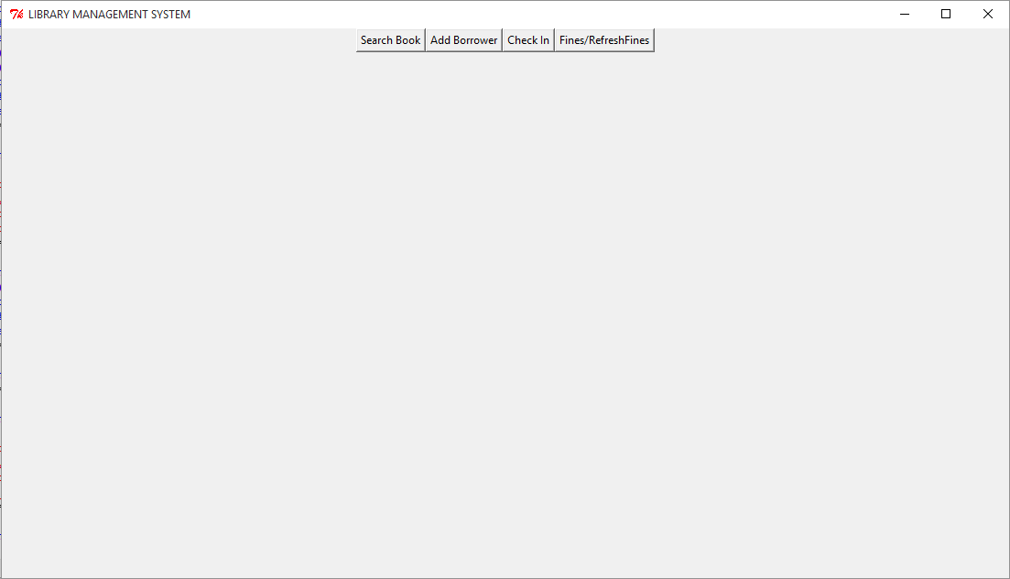

On clicking Search Book:

A text box and a button appears. To search a book in the system just enter the works in the textbox and click Search Button, right to the text box.

Screenshot 2: On Clicking Search Book from Menu

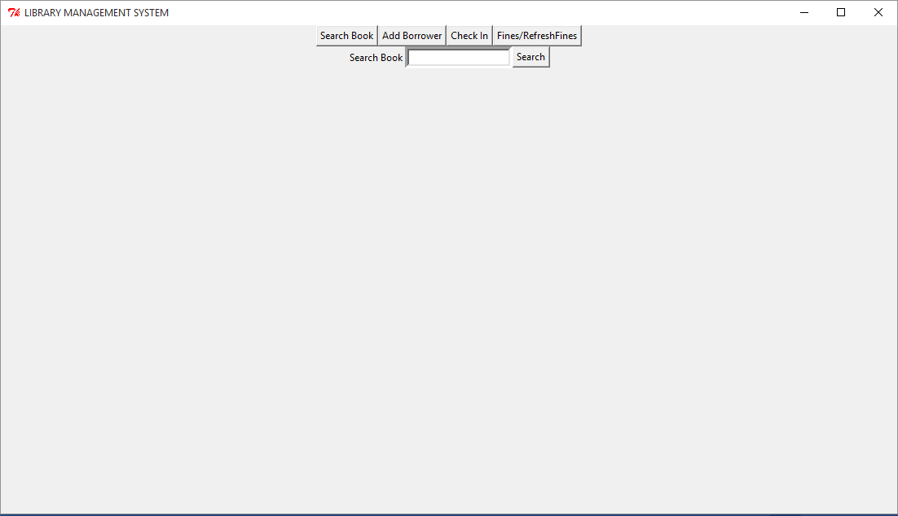

For example to search “Schindler’s”. Enter “Schindler’s” in the text box and click Search Button.

Screenshot 3: On Searching a Book by Clicking Search Button

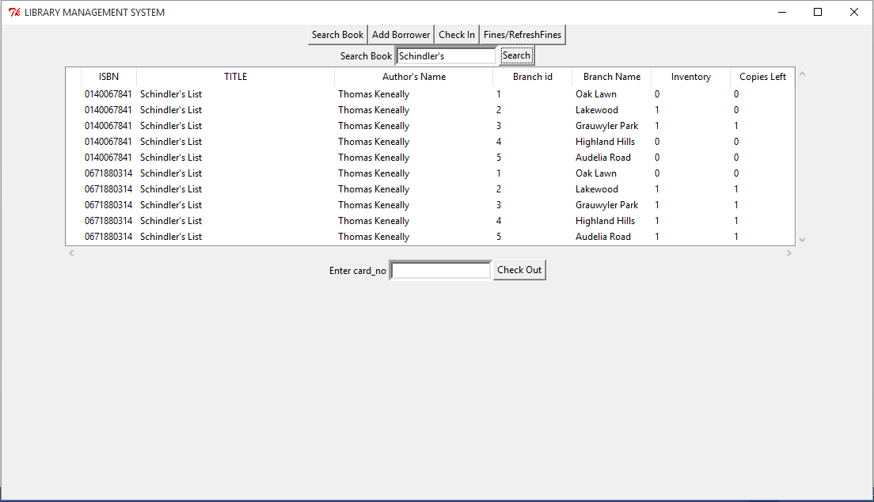

TO CHECKOUT A BOOK:

First select a row from the search results corresponding to the book you want to check out. Then enter the card_no of the borrower in the text box and click Check Out

Screenshot 4: On starting the application

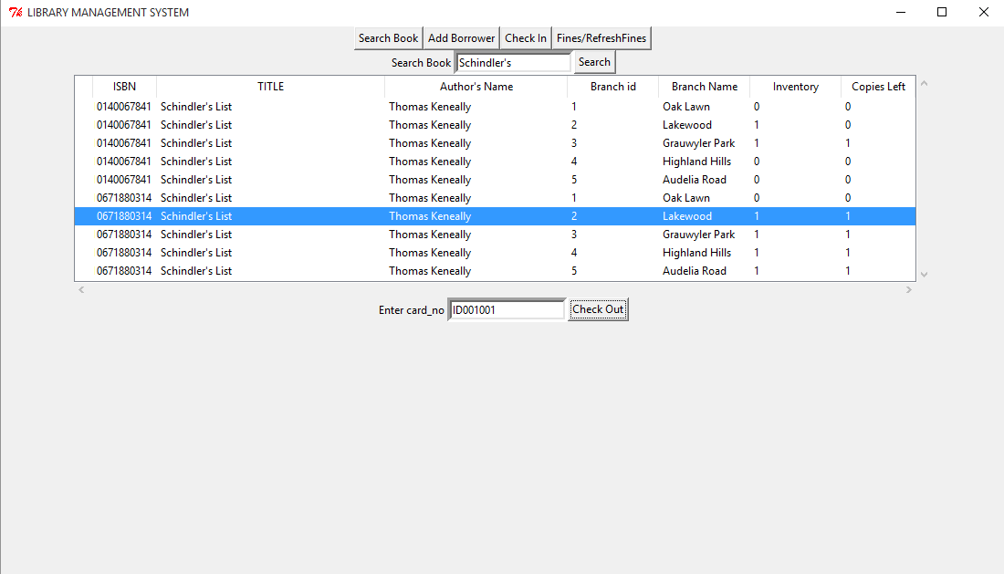

TO ADD A BORROWER:

Enter all the fields and click submit button.

Screenshot 5: On Clicking Add Borrower from Menu Buttons

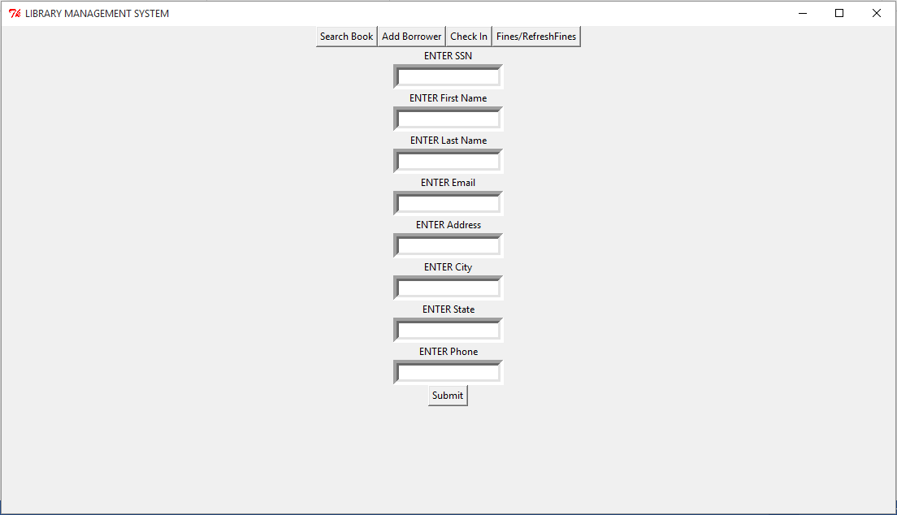

TO CHECK IN:

To check in book first click check-in from the menu buttons. A textbox and Search button appears. Enter ISBN, card_no and/no borrower’s name to see all the books which have not been checked-in the system.

Once the results are displayed in the table, select a row corresponding to a loan you want to check-in, then enter the no of days from date-out to check-in in the textbox below and click Check-In Book Button.

Screenshot 6: After Searching a Loan Transaction for Check-In

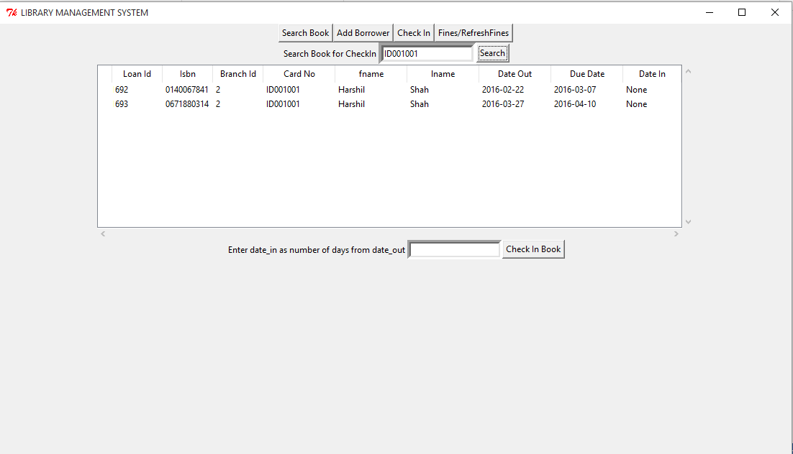

FINES/REFRESH FINES:

To display the fines which are still to be paid click Fines/Refresh Fines from the Menu Button.

The display shows fines relating to the Loan ID. To see user wise fine Click USER WISE FINE button in the bottom.

Screenshot 7: On Clicking FINES/REFRESH FINES Loan-Id wise fines displayed

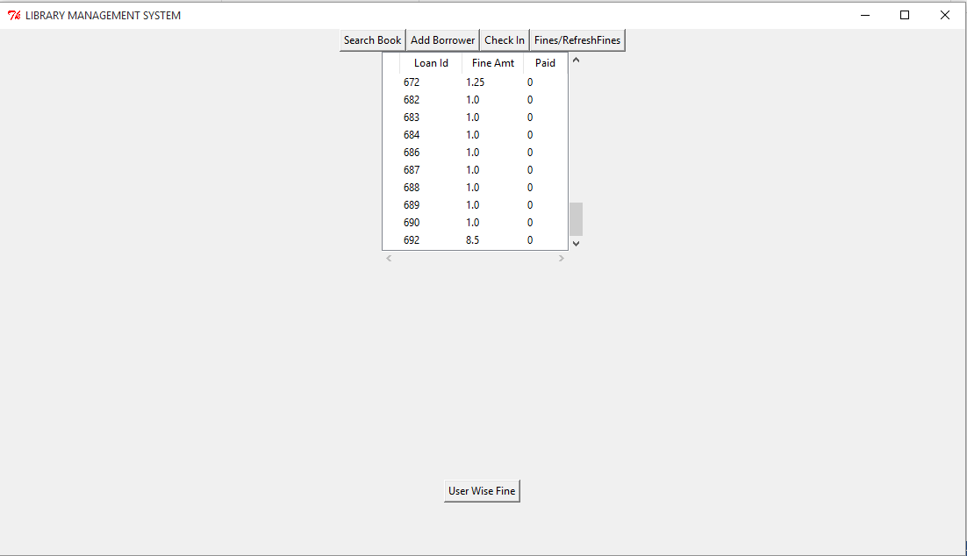

Screenshot 8: User wise fines displayed

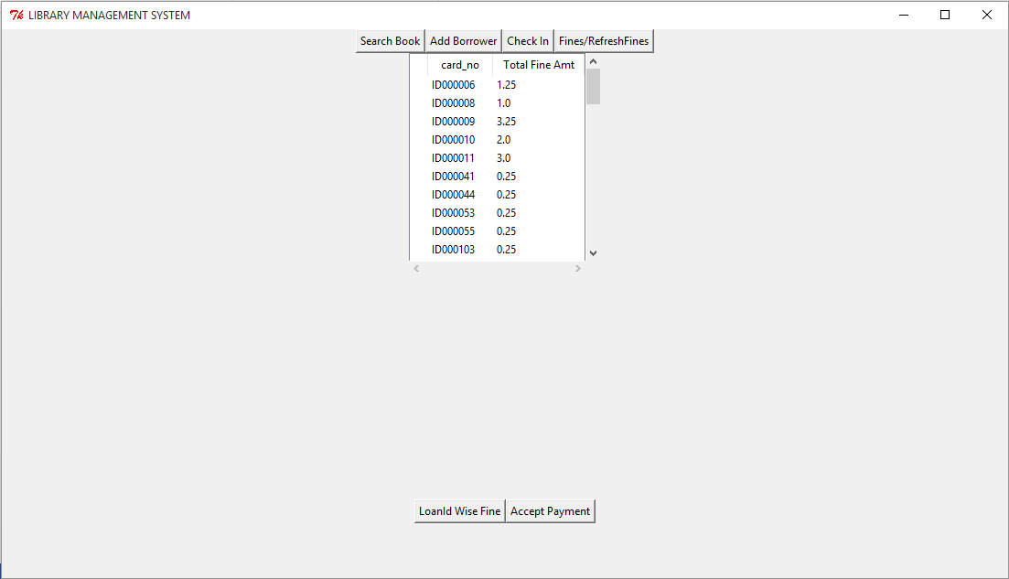

Thank you